# **HEALTH CARE SYSTEM:**

# 

# 

|  |  |  |
| --- | --- | --- |
| **Supervisor** | SIR MUHAMMAD HARIS | |
| **Batch** | 2405G2 | |
| **Group** | **B** | |
| **Serial No.** | **Enrollment Number** | **Student Name** |
| 1. | Student1552011 | Muhammad Bin Adeel |
| 2. | Student1572866 | Muhammad Huzaifa |
| 3. | Student1571601 | Muhammad Khizar |
| 4. | Student1572862 | Muhammad Arbaz |

**Problem Statement**

We all need to visit doctors some time or the other. Sometimes it is an emergency situation, whereas most of the other time it is a planned checkup/visit. But in both the cases we have to visit the doctor to take an appointment or wait in long queues.

CARE Group is into medical services for long time and looking at the current medical scene have decided to come up with a WEBSITE, which will host the medical services available in different cities.

Individuals will be able to search for specialist doctors in their surroundings and even book online appointments.

Web site should also record the complete information regarding the Doctors and Patients.

**Customer Specifications:**

Website will host information about common Diseases, and Cures. It will also display the latest medical news and information on inventions in Medical Science.

The website will have three users/roles:

1. Administrator
2. Doctor
3. Patient

The Administrator should be able to do the following:

1. Add Cities to the master database.
2. Add Doctors to the Master database.
3. Modify Doctor Details.
4. Modify Patient Details.
5. Delete Cities
6. Delete Doctors
7. Delete Patients
8. Create/Manage Users/Logins
9. Manage information/details on the WEBSITE

The Doctor should be able to do the following:

1. Login into the system with his USER/PASSWORD
2. View his/her profile details
3. Add details to his/her profile
4. Modify his/her profile
5. View Appointments
6. Update his availability for DAY/WEEK/MONTH

The Patient should be able to do the following:

1. Register/Create Account [USERID should be unique].
2. Search Doctor based on location, Specialist
3. Book Appointment [Check Availability]

Note: Name, Address, Phone Numbers, Email-ids should be mandatory to be provided.

**Hardware/ Software Requirements**

**Hardware**

* A minimum computer system that will help you access all the tools in the courses is a Pentium 166 or better
* 128 Megabytes of RAM or better

**Operating System**

* LINUX / Windows 2000 Server (or higher if possible)

**Software**

* PHP
* MySQL
* PERL
* Apache

### **Acknowledgement**

I would like to express my deepest gratitude to Almighty Allah, whose blessings enabled me to successfully complete this project titled **"Care Project"**.

I am sincerely thankful to my respected teacher, **[Teacher’s Name]**, for their continuous support, guidance, and encouragement throughout the project. Their valuable suggestions and feedback helped me stay focused and improve the overall quality of the work.

I would also like to extend my appreciation to **[Institute/University Name]** for providing the resources and platform to carry out this project effectively.

My heartfelt thanks go to my family and friends for their moral support and motivation during the entire duration of this project.

Finally, I would like to thank all those who directly or indirectly contributed to the success of this project.

4o

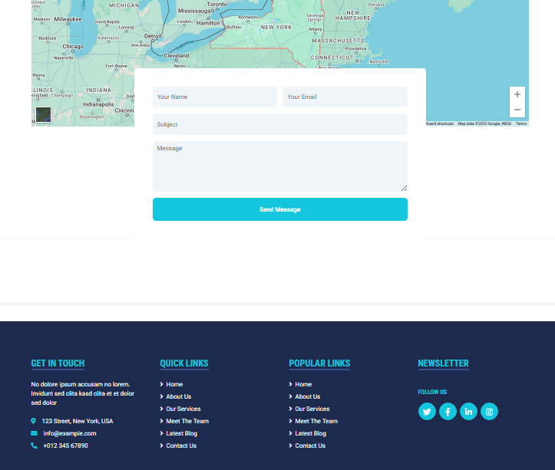

**Task Sheet Review:**

|  |  |  |  |  |  |  |
| --- | --- | --- | --- | --- | --- | --- |
|  | | **Project Title** | **Date of Preparation of Activity Plan** | | | |
| No. | **Task** | **Health** | Actual | Actual | Name | Status |
| Start date | Days |
| 1 | Admin Panel | CARE | 29/APRIL/25 | 5 | Muhammad Huzaifa | Complete |
| 2 | Doctor Panel | CARE | 4/MAY/25 | 5 | Muhammad Bin Adeel | Complete |
| 3 | Feedback Form | CARE | 9/MAY/25 | 4 | Muhammad khizar | Complete |
| 4 | Build Appointment Form | CARE | 15/MAY/25 | 3 | Muhammad Khizar | Complete |
| 5 | Blogs and Diseases Page | CARE | 18/MAY/25 | 5 | Muhammad Huzaifa | Complete |
| 6 | Doctors Cards | CARE | 24/MAY/25 | 3 | Muhammad Bin Adeel | Complete |
| 7 | Signup Sign in Form | CARE | 27/MAY/25 | 3 | Muhammad Arbaz | Complete |
| 8 | Frontend | CARE | 29/MAY/25 | All DAYS | Muhammad Huzaifa  Muhammad Bin Adeel  Muhammad Khizar  Muhammad Arbaz | Complete |

**Summary:**

The **CARE Project** is a web-based healthcare management system designed to simplify and improve communication between patients, doctors, and administrators. Through this system, patients can book appointments online, doctors can approve them, and the admin panel manages all related data efficiently. Built using PHP, MySQL, HTML, CSS, and JavaScript, the platform offers a responsive and user-friendly interface. The primary goal of the CARE system is to digitize healthcare processes, save time, and enhance the overall quality of medical services.Top of Form